User Manual

FMS^{NG} Application

Shell Energy Marketing and Trading India Private Limited
Project Sponsoring Business

Transport Module

18 MAR 2024
Date

Table of Contents
1. Transport Module Overview 3
1.1. User Interface / Screen Designs 3
2. Menu Network / Screen Navigation 4
2.1. Sub Module – GTA 4
2.2. Sub Module – GTA Remittance 11
2.3. Sub Module – Map Master 21
3. Report Design and Layout 24
3.1. Sub Module – GTA Reports 24
4. Auditing 26

Transport Module Overview
FMS^{NG} Application is an efficient ETRM System for Domestic Gas Trading, customized to meet business requirement of Shell Energy Marketing and Trading India Private Limited (SEMTIPL).
FMSNG Transport Module will create and manage Transporter contract and associated transport workflow of the trading system as listed below:

• GTA Agreement Creation & Management
• GTA Deal Creation & Management
• Transporter Customer code and CT Management
• Daily Nomination, Scheduling and Gas Allocation
• Remittance Generation
• Interfacing with SAP P80 to flow Financial Information
• System will trigger event based emails as applicable
• Management Reports

User Interface / Screen Designs

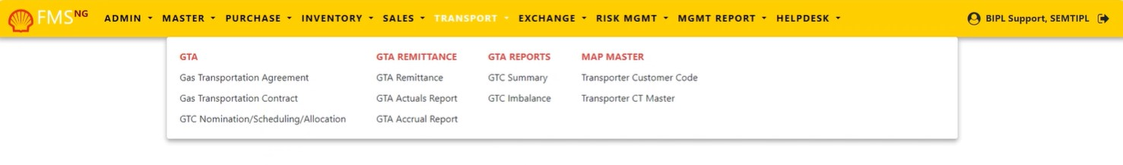
FMS^{NG} offers Responsive UI to enable usability via any smart phone, tab and laptop of any screen size. The Menus of Transport module are as below:

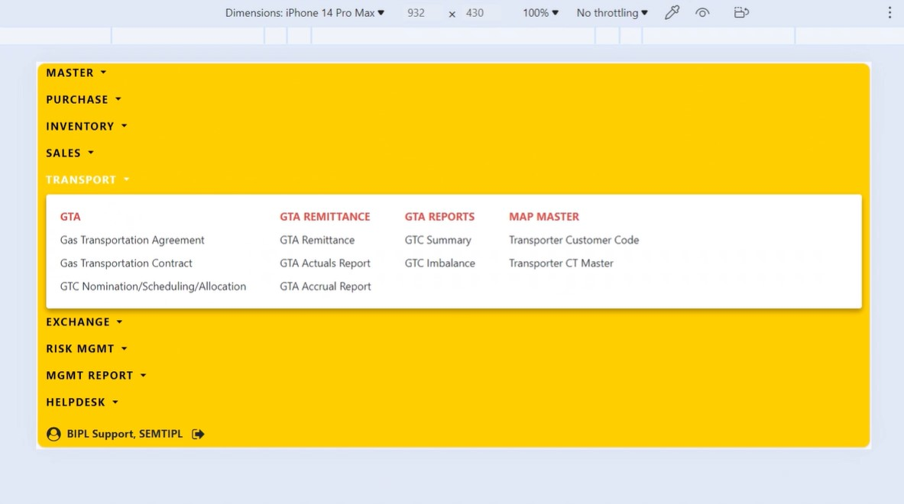
The responsive mode view over iPhone simulation:

Menu Network / Screen Navigation
Menus in any Module are kept under different Groups for better categorization. The Groups under Transport Module are Contract, Request/Approval, Nomination, Allocation & Metering, Invoice, Reports.

Sub Module – GTA

‘GTA Group contains FORMs for Create and Modify Gas Transport Agreement, Gas Transport contracts and GTC Nomination/Scheduling/Allocation.

GTA – Gas Transport Agreement

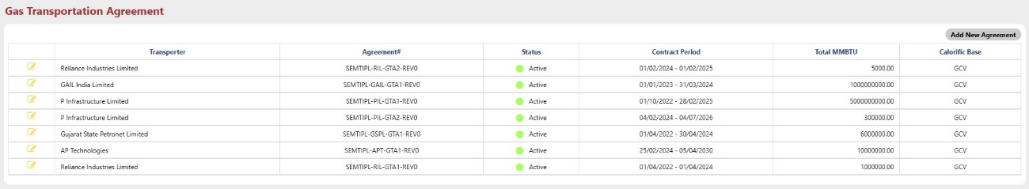
Agreement for Transporter in FMS^{NG} Application added/edited from this FORM by Users who have access of Sales Module.

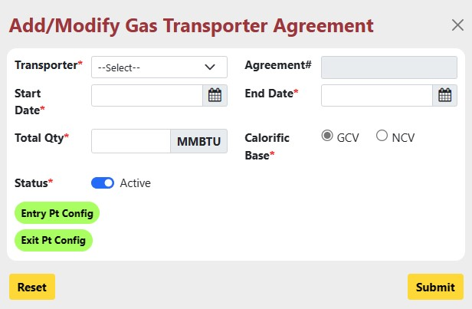
To add a new Agreement, click on “Add New Agreement” at the right Top corner and enter required details or to Modify Contract, click on button and change details for existing agreement.

- Transporter: Select Transporter from the dropdown for which Agreement will be generated.
- Agreement#: Agreement number is automatically entered by the system.
- Start Date: Enter Start date for the Agreement.
- End Date: Enter End date for the Agreement.
- Total Qty: Enter quantity for the Agreement.
- Calorific Base: Select whether GCV or NCV.
- Status: Set status whether active or Inactive.
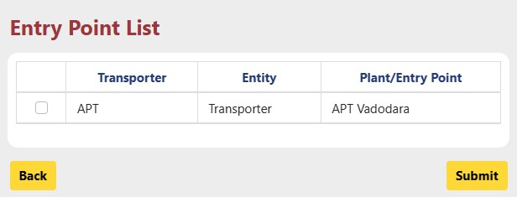
- Entry Pt. Config: Select entry point for selected transporter using “Entry Pt. Config” button.

- Exit Pt. Config: Select Exit point using “Exit Pt. Config” button.
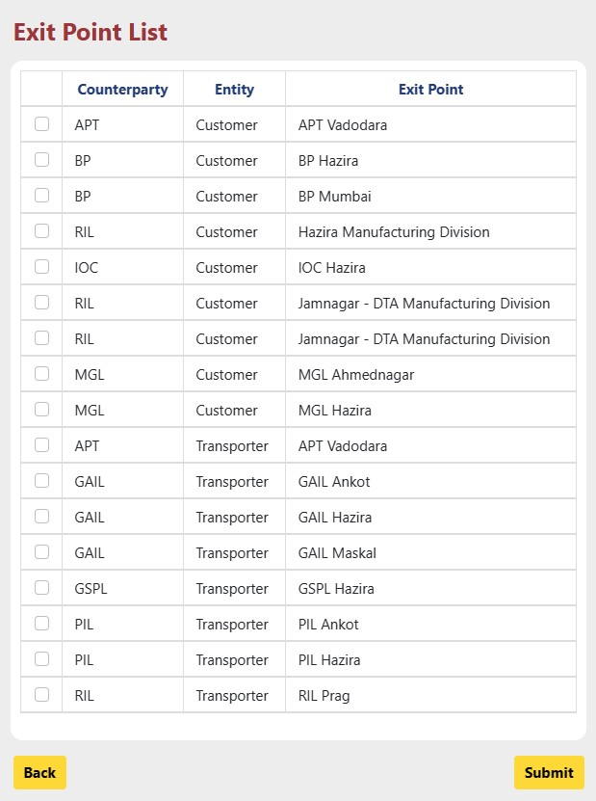
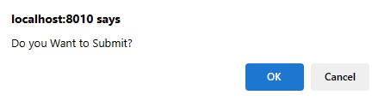
After inserting all the details, click on “Submit” Button. A dialogue box asking your permission to Create New Agreement appears as shown below:

Press Ok. The status of Agreement Creation in system get displayed on the top of the screen.

GTA – Gas Transportation Contract

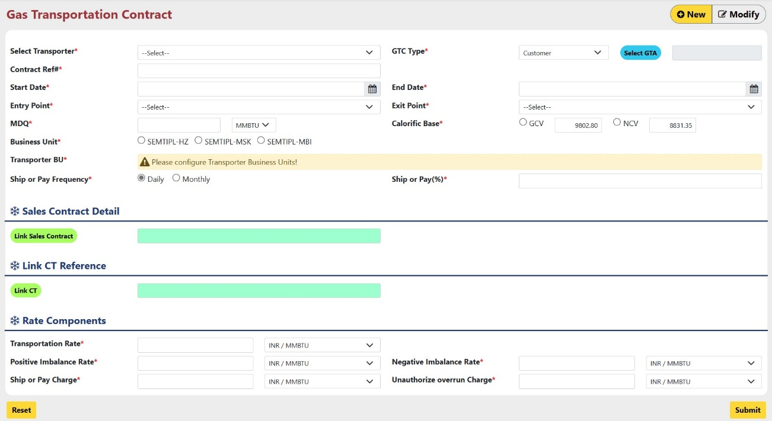
Contracts of Transporters in FMS^{NG} Application added/edited from this FORM by Users who have access of Transporter Module.

To add a new Contract, click on New at the right Top corner and enter required details or to Modify Contract, click on Modify at the right Top corner and change required details:
- Select Transporter: Select Transporter from Dropdown.
- GTC Type : Select GTC type whether Customer or Transporter from the dropdown
- Select Agreement: Select agreement for selected Transporter using “Select GTA” button.
- Contract Ref#: Enter Reference number for Contract.
- Start Date: Enter Contract Start date.
- End Date: Enter contract End date.
- Entry Point: Select Entry point for the selected Transporter.
- Exit Point: Select Exit Point from the dropdown.
- Gas Price: Enter Gas Price and Currency for the Contract.
- MDCQ: Enter Maximum Daily Contractual Quantity for the contract.
- Calorific Base: Select Calorific Base whether GCV or NCV.
- Business Unit: Business unit are selected as per the Selected Agreement.
- Transporter BU: Select Transporter Business Unit for selected Transporter.
- Ship or Pay Frequency: Select Frequency for Ship or payment.
- Ship or Pay (%): Enter percentage for ship or payment for the selected frequency.
- Link Sales Contract: If “GTC Type” is “Customer”, then Link existing sales contract according to Exit point using “Link Sales Contract” button.
- Link CT: Select CT using “Link CT” button.
- Transportation Rate: Enter transportation rate for the transporter.
- All other fields are automatically selected as per the Transportation Rate, User can change that values as per the requirement.

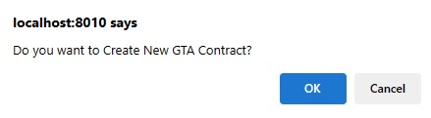
After inserting all the details, click on “Submit” Button. A dialogue box asking your permission to Create New Gas Transportation Contract appears as shown below:

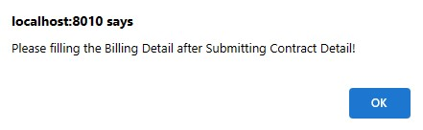
Click “Ok” on next dialogue box.

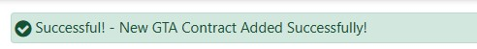
Press Ok. The status of Contract Creation in system get displayed on the top of the screen.

After that Select Configure Billing : Configure Billing Details for the Contract.

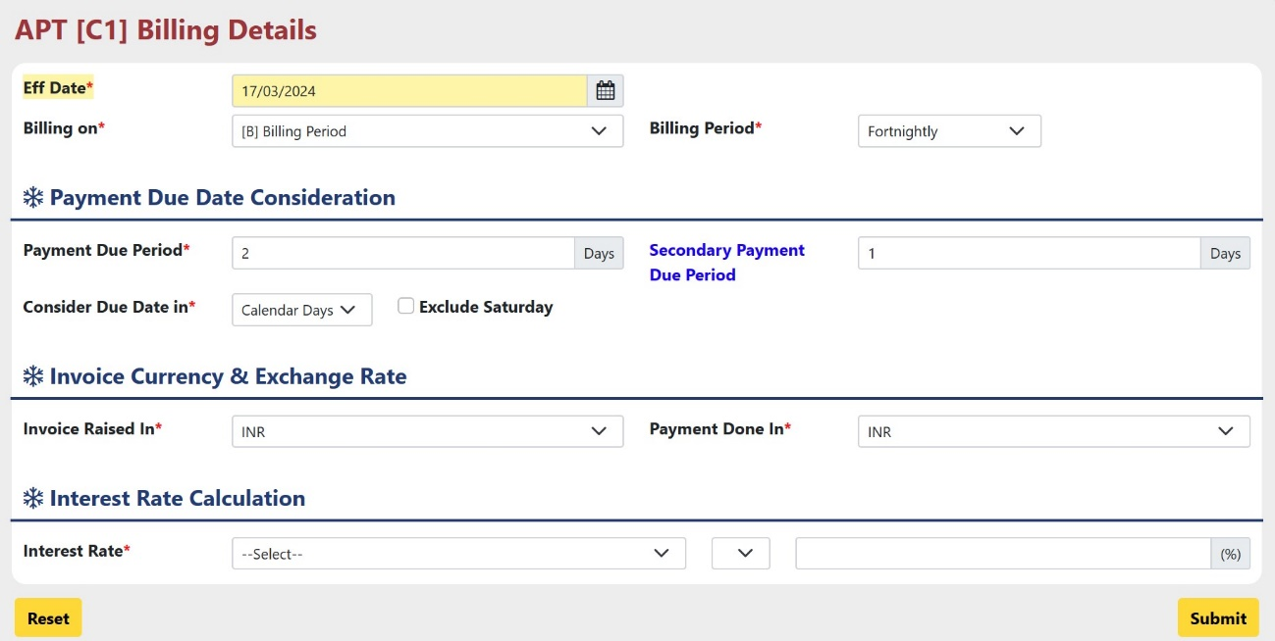
- Enter Data according to requirement.

Submit Billing Details, Close the Billing Detail Page.

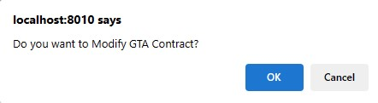
After that, click on “Submit” Button. A dialogue box asking your permission to Modify Contract appears as shown below:

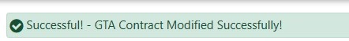
Press Ok. The status of Contract Creation in system get displayed on the top of the screen.

GTA – Nomination/Scheduling/Allocation

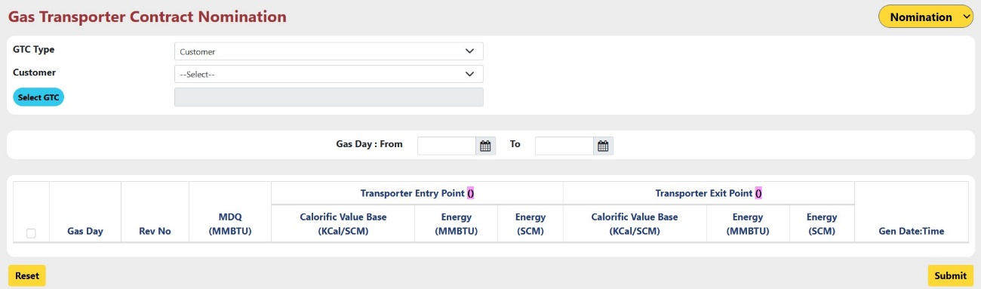
Using this form, User can do nomination, Scheduling and Allocation for the Existing Gas Transporter Contract.

- Select whether Nomination, Scheduling or Allocation have to be done from the Dropdown located at the Top Right Corner.
- First, Nomination have to be done for the contract.
- GTC Type: Select GTC type from the dropdown.
- Customer/Transporter: Select Customer or Transporter from the dropdown according to the GTC Type.
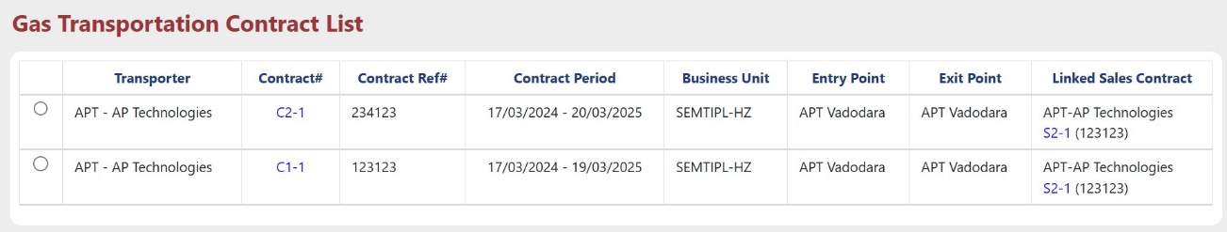
- Select GTC: Select available contract from the GTC List.

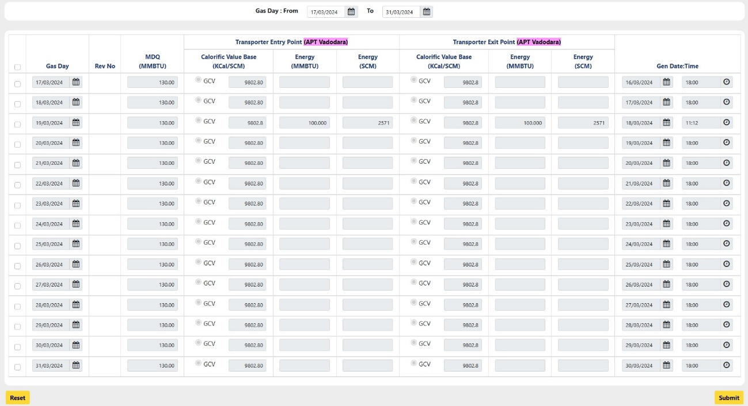
- Select checkbox for the date for which Buyer and seller nomination has been done from Sales module for the linked sales contract.
- Click on “Submit” to save the nomination for Transporter.
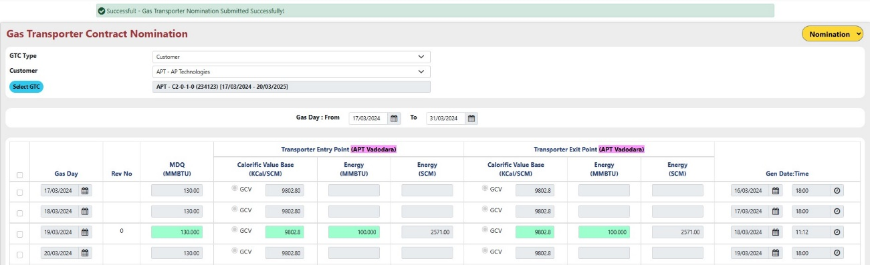
- The status of Nomination submission in system get displayed on the top of the screen and the Energy(MMBTU), Calorific Value Base fields will be highlighted with green color :

- Follow same process for Scheduling and Allocation also in the same order.

Sub Module – GTA Remittance

GTA Remittance – GTA Remittance

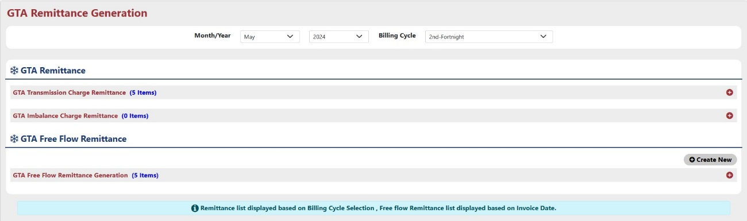
GTA Remittance is used for generating Invoice for Trader. User can create GTA free flow. Remittance.

User can select “Month/Year” and “Billing Cycle” from the dropdown for which remittance will be generated.

Method 1 : Here are the steps for GTA Remittance Preparation:


- Click on button to Prepare remittance for which user wants to generate remittance. The popup new screen will open shown as below.
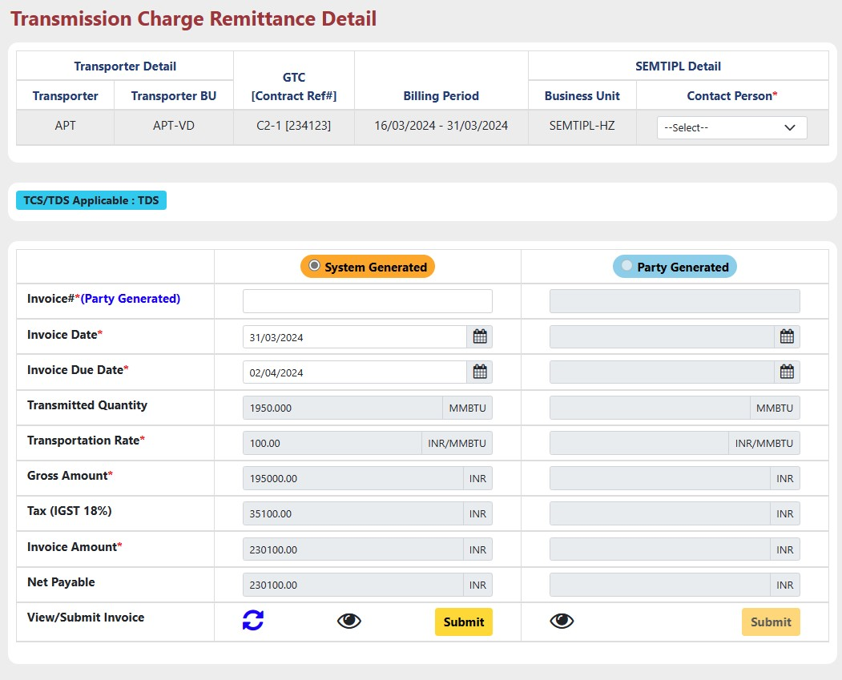
- Select Contract Person from the drop down for both, Business details.
- Here, Two types of Invoice details can be entered, “System Generated” and “Party Generated”.
- In System Generated part all the details will be filled by the system by itself according to the contract details.
- In Party Generated part all the information will be entered by the trader.
Note*: Party Generated part will be enabled only after check remittance part will be completed for System generated Invoice.

- Fill all the required details.
- Use button to reset all the fields.
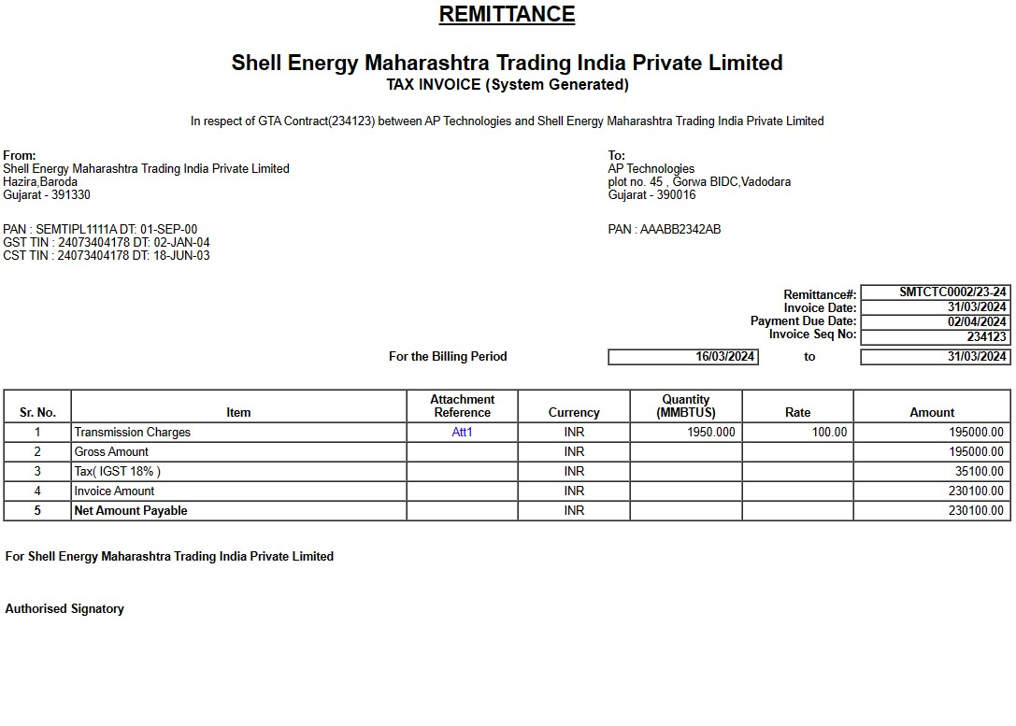

- Use button to view how the invoice will be look like.
- Click on “Submit” button to submit all the details and prepare remittance.

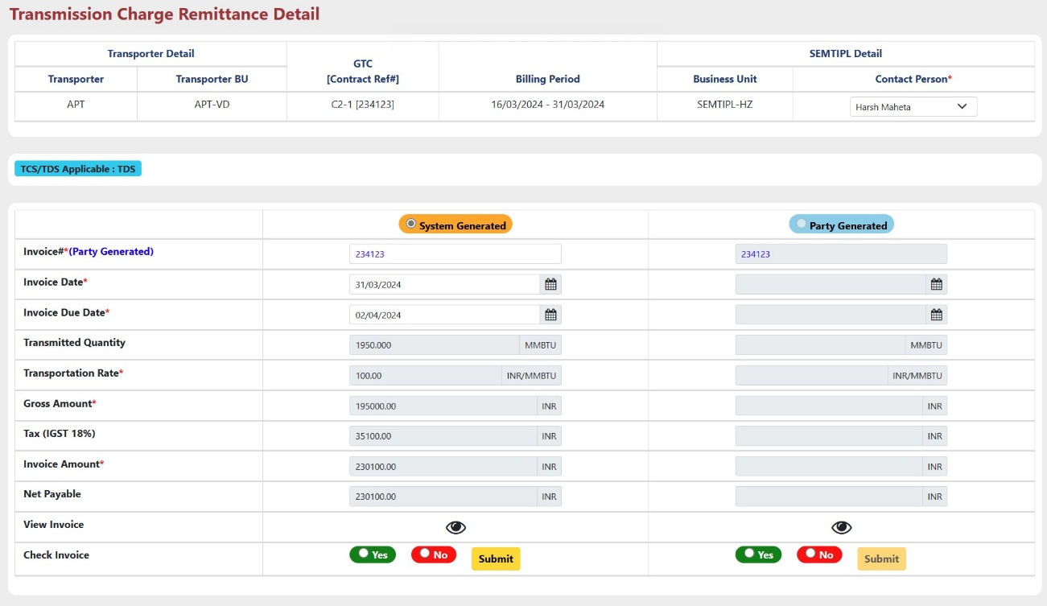


- After that button will be enabled. Use button to check whether all the details entered for remittance is correct or not.

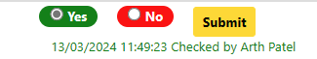
- Select “Yes” or “No” in order to check invoice and Click “Submit” button to submit response.
- After submission, this type of message will appear.

- After that button will be enabled. Use button to Authorize remittance details.
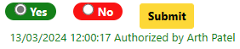
- To authorize Remittance details, Select “Yes” or “No” and then click “Submit” button.
- After submission, this type of message will appear.

- After that button will be enabled. Use button to Approve or Reject remittance details.
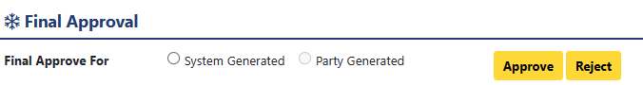

- Select “System Generated” or “Party Generated”, for which type invoice further process will execute. And then click “Approve” or “Reject” button.
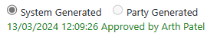

- After Approval, this type of message will appear.
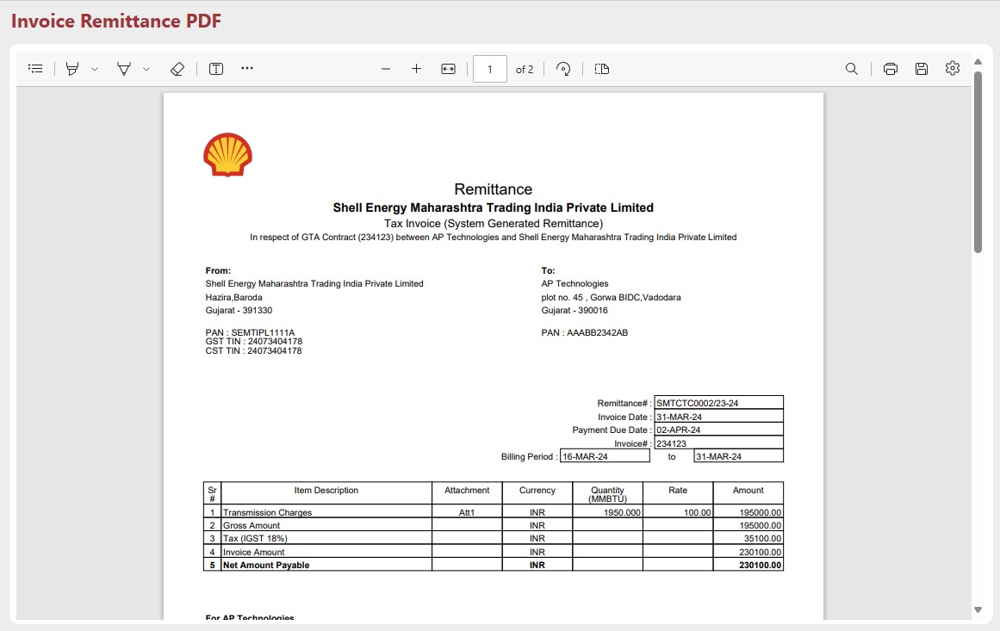
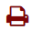
- After that, click on button in order to generate PDF.



- After generation of PDF, icon converted into icon. And all the other buttons will be disabled.
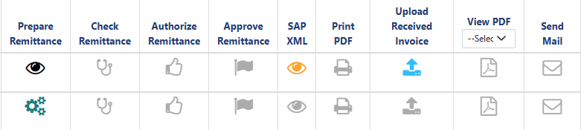

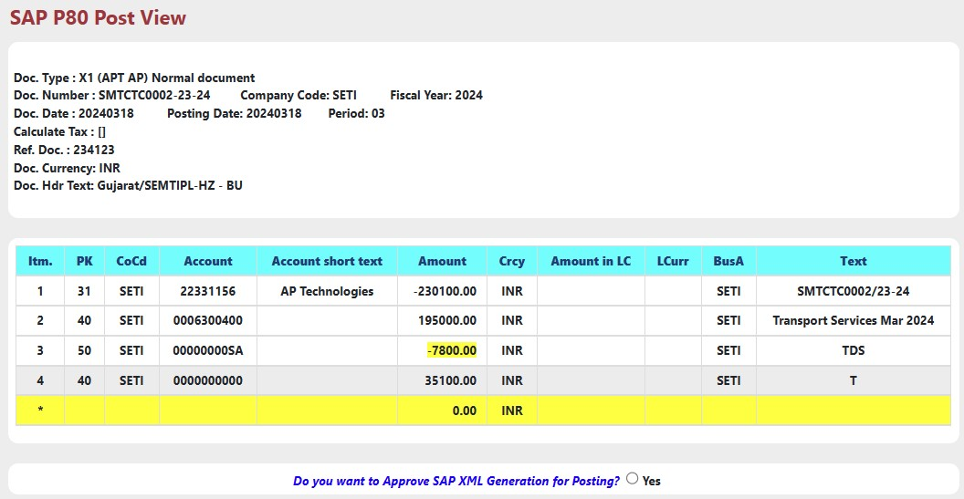
- After that, click on button in order to approve SAP-XML.
- Select “Yes”, to approve SAP XML generation for posting. After successful approval below message will appear.

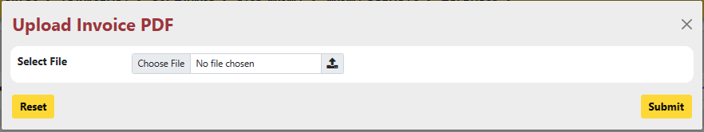

- User can Upload Received Invoice from the party i.e. Party Generated Invoice using button.

- Select PDF file from your system and click “Submit” button.

- After Submission icon will be converted to icon.

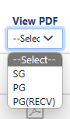
- User can view Invoice in pdf format by selecting type of Invoice from the dropdown.

- Here SG : System Generated
PG : Party Generated
PG(RECV) : Party Generated Received (Uploaded using button.)

- After Selecting any type, if PDF file is available then will be enabled and will be look like .
- User can view PDF using button.

- User can send mail directly from this form using button only after uploading received Invoice.
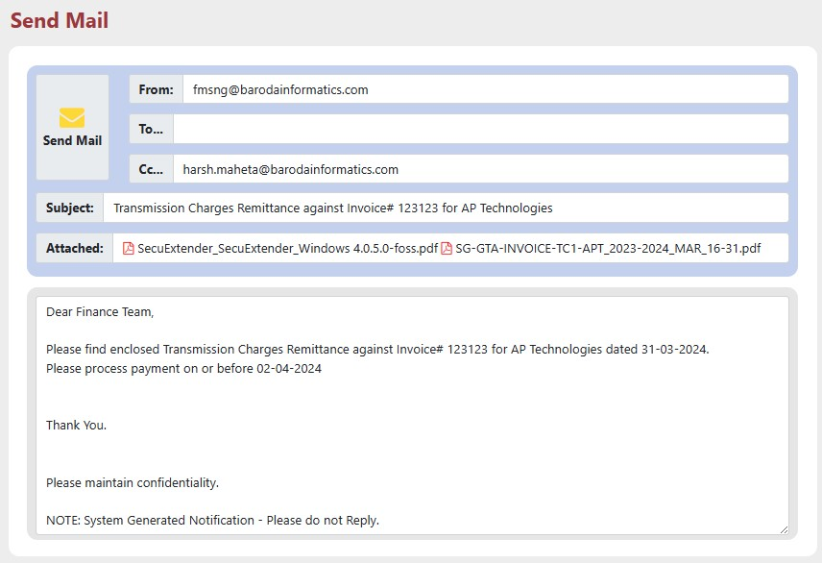
- Click on “Send Mail” Button to send mail.

Method 2 : Follow below steps to Generate GTA Free Flow Remittance :

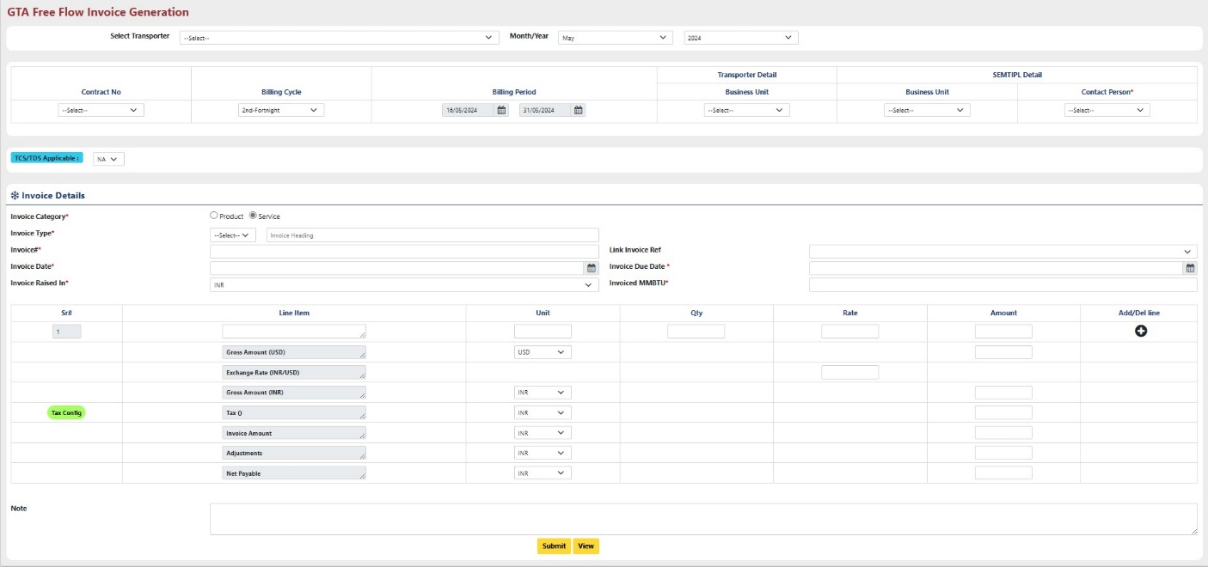
- Click On “Create New” button located at the top right corner of the ‘GTA Free Flow Remittance Generation’ Part.

- Select Transporter: Select Transporter from the dropdown for which Remittance will be generated.
- Month/Year: Select month & year from the dropdown.
- Contract No. : Select Contract for the selected Transporter from the existing Contracts.
- Billing Cycle: Select billing cycle according to the requirement.
- Business Unit (Transporter Details): Select Business Unit for which Remittance will be generated.
- Business Unit (owner (SEMTIPL) Details): Select Business Unit from the dropdown.
- Contact Person (owner (SEMTIPL) Details): Select Contact person from the dropdown.
Note*: It is mandatory to select Business Unit First and then only Contact Person can be selected.
- TCS/TDS Applicable: If “TCS” or “TDS” applicable on the invoice, select from the dropdown, else Select “NA” to proceed further.
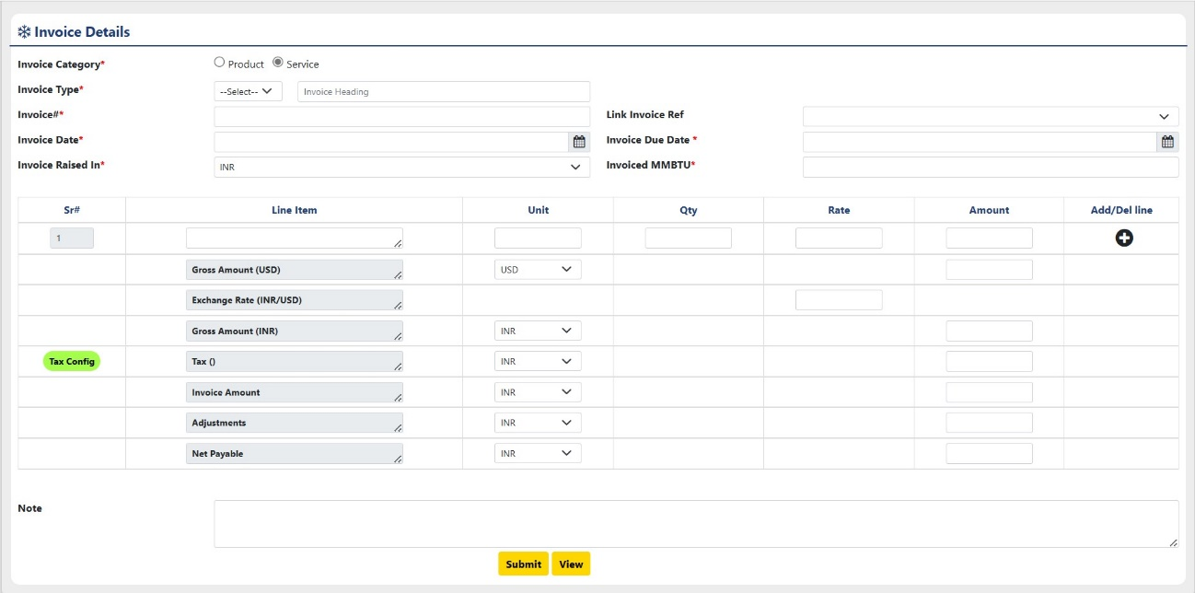

- Invoice Category: Select Invoice Category, for which category invoice will be generated.
- Invoice type: Select Invoice Type from the Dropdown.
- Invoice#: Enter invoice number.
- Link Invoice Ref: Link reference with invoice if any available.
- Invoice Date: Enter date on which invoice will be raised.
- Invoice Due Date: Enter due date for invoice.
- Invoice Raised In: Select In which Currency Type Invoice will be raised.
- Invoiced MMBTU: Enter quantity of Gas in MMBTU unit, for how much of quantity Invoice will be generated.
- Line Item: User have to enter Name of Item (Product or Service) for which Invoice will be generated at the first Row of Line Item Column.
- Unit: Enter Unit as “INR” or “USD” as per the item’s amount.
- Qty: Enter quantity of item.
- Rate: Enter Rate of the Item.
- Amount: Enter Price of Item.
- Add/Del Line: User can add more lines in order to add more item.
- Gross Amount (USD): Enter Gross Amount in USD in Amount Column.
- Exchange Rate: Enter your preferred exchange rate from USD to INR.
- Gross Amount (INR): Enter Gross Amount in INR according to exchange rate.
- Tax (): Configure tax details by using “Tax Config” button.
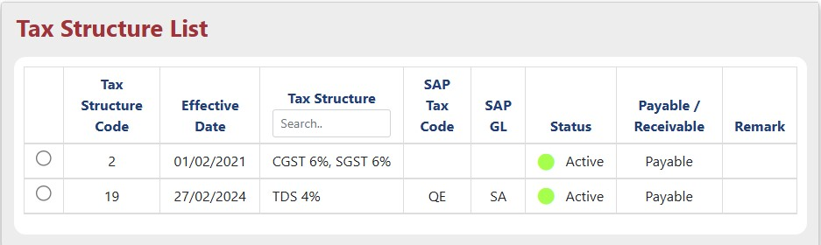
Select preferred tax from the list. Enter Tax amount in amount Column.
- Invoice Amount: Enter Total amount of Invoice in amount column.
- Adjustment: Enter amount of adjustment if applicable.
- Net Payable: Enter the final payable amount after Adjustment will be paid.
Note: User can add some note for future reference.

Click “Submit” button to submit all the details.
After Successful submission, User can see how invoice view will be like by using “View” button.

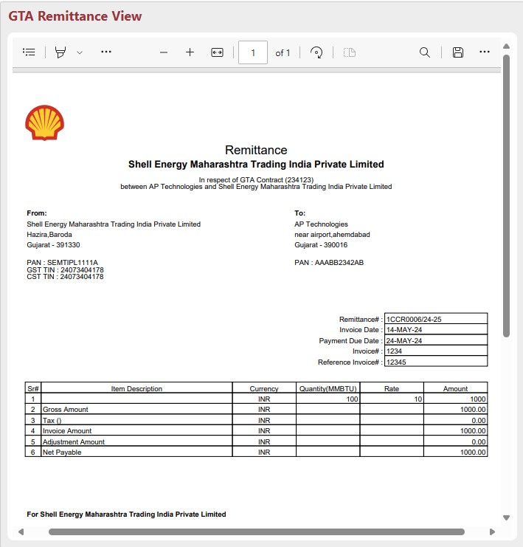

2. After that, the further process is exactly the same as explained in “Method – 1” .

GTA Remittance – GTA Actual Report

GTA Actual Report will be generated for the Contracts after Invoice were generated.
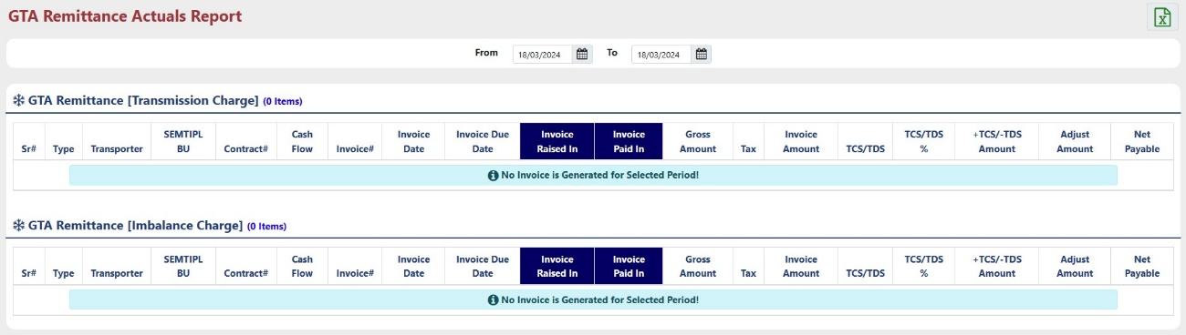
Increase Date Range by changing ‘From’ and ‘To’ date.
GTA Actual Report contains all the information about Contract and Invoice Raised for available contracts.
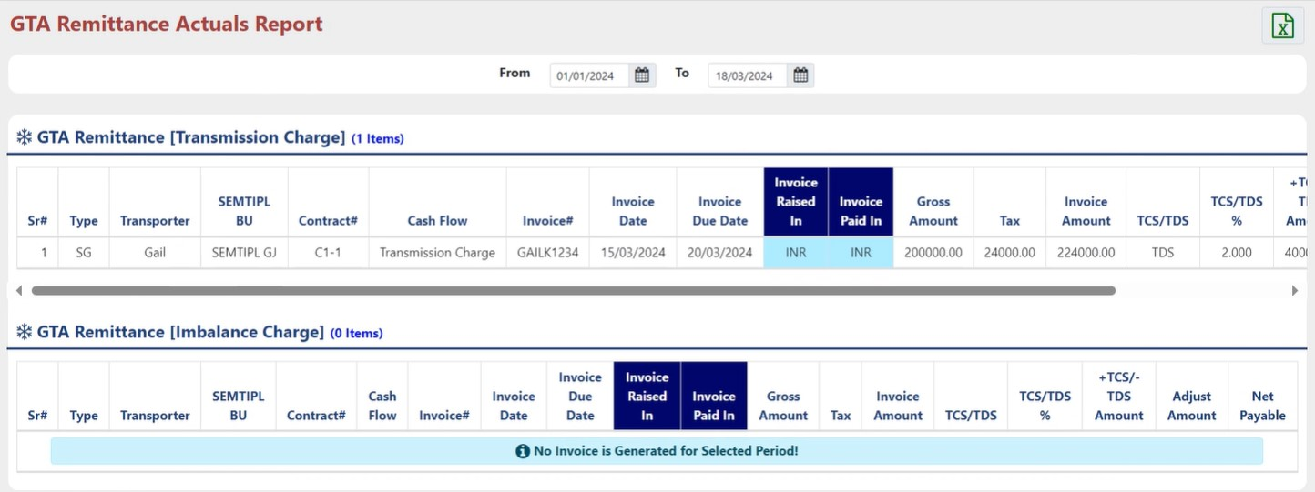

GTA Remittance – GTA Accrual Report

GTA Accrual Report will generated before the Invoice were generated.
This Report contains all the Information about contract and accrual Gas amount.
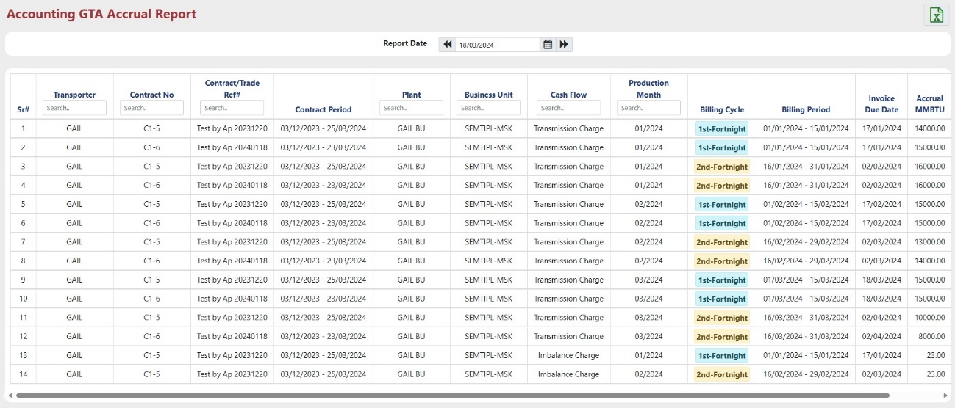

Sub Module – Map Master

Map Master – Transporter Customer Code

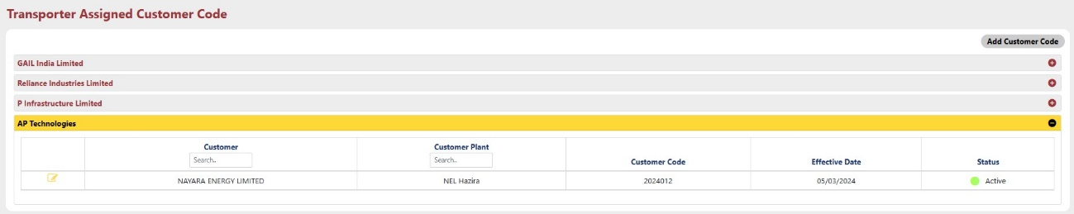
Transporter Customer code menu is used for assigning specific code to customer by transporter for reference.

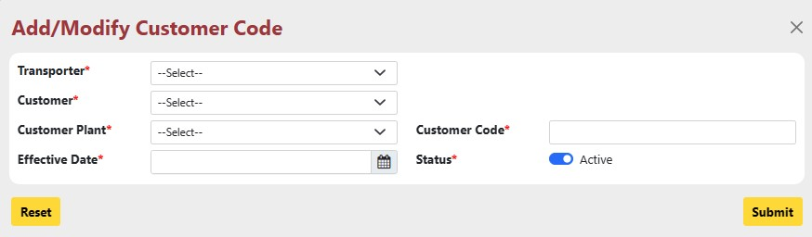
To add a new Customer code, click on “Add Customer Code” at the right Top corner and enter required details or to Modify Customer code, click on button and change details for existing Customer code.

- Transporter: Select transporter from the dropdown.
- Customer: Select customer for which code will be generated.
- Customer plant: select customer plant for the selected customer.
- Effective Date: Enter effective date for the customer code.
- Status: Set status of the customer code.

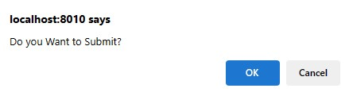
After that, click on “Submit” button to save the details.
Click “Ok”, status of Customer code submission or modification get displayed at the top of the screen.

Active Assigned customer cod get displayed at the time of nomination through “Sales” Module.

Map Master – Transporter CT Master

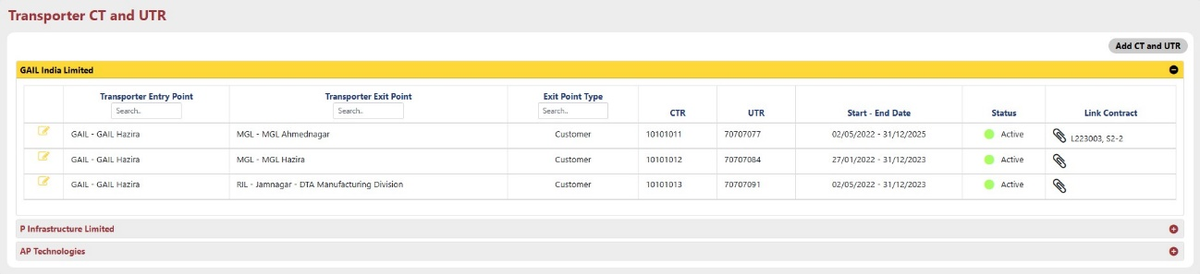
Transporter CT Master Menu is used for generating tickets for the entry and exit point for the transporter reference.

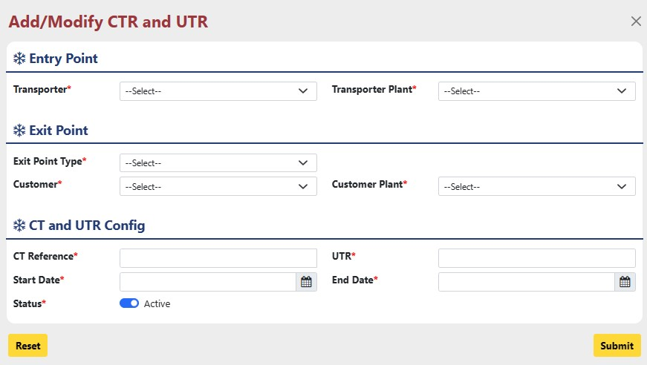
To add a new CT or UTR, click on “Add CT and UTR” at the right Top corner and enter required details or to Modify CT/UTR, click on button and change details for existing CT/UTR.

- Transporter: Select Transporter Entry point.
- Transporter Plant: Select transporter plant for the selected transporter.
- Exit point type: Select exit point type whether Customer or Transporter.
- Customer/Transporter: Select Customer/Transporter name for exit point.
- Customer/Transporter plant: Select Customer/Transporter plant for the selected customer/transporter.
- CT Reference: Enter Reference for the CT.
- UTR: Enter UTR value as per the requirement.
- Start Date: Enter Start date.
- End Date: Enter End Date.
- Status: Set status for the CT and UTR.

After that, click on “Submit” button to save the response. Status of the CT/UTR get displayed on top of the screen.

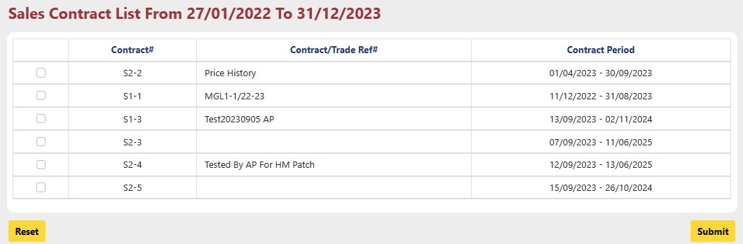
User can link CT/UTR with existing sales contract using button.

User can select multiple sales contract to link with the CT/UTR.
Select contract/s and click on “Submit” button.
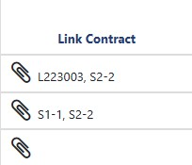
Selected contracts get displayed after button.

Active Assigned CT/UTR get displayed with the linked contract at the time of nomination through “Sales” Module.

Report Design and Layout

Sub Module – GTA Reports

‘GTA Reports’ Group contains REPORTs for all the Transporter side Contract Details.

GTA Reports – GTC Summary

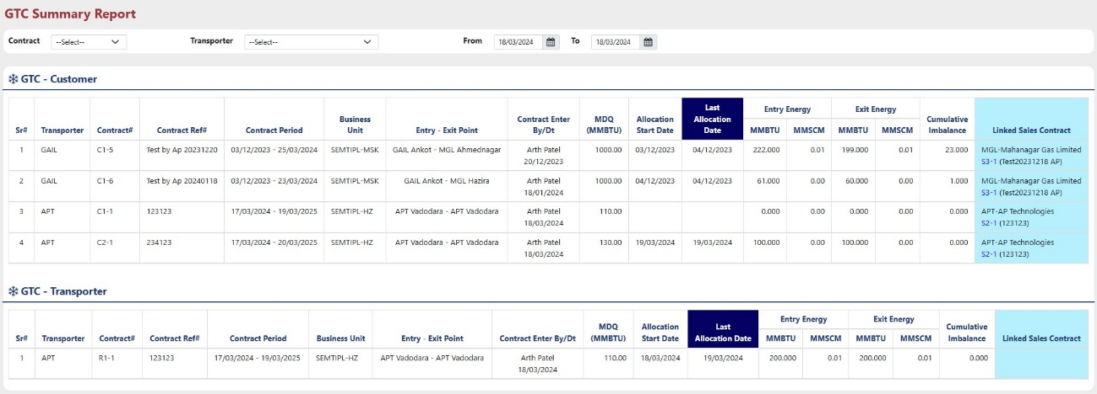
GTC Summary gives all the Information about all the GTA contracts.
- Contract: User can filter data according to Contract type by selecting from the dropdown
- Transporter: User can filter data according to transporter by selecting from the dropdown.
- User can increase or decrees time span for data by selecting “From” and “To” date.

GTA Reports – GTC Imbalance

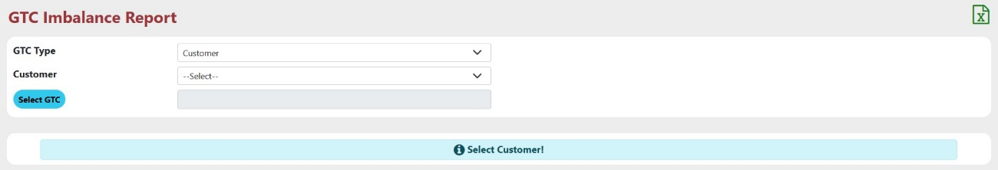
This Report contains Information of Nomination, Scheduling and Allocation according day wise.

- GTC Type: Select customer or transporter from the dropdown.
- Customer/Transporter: Select Name of customer/Transporter according to GTC type.
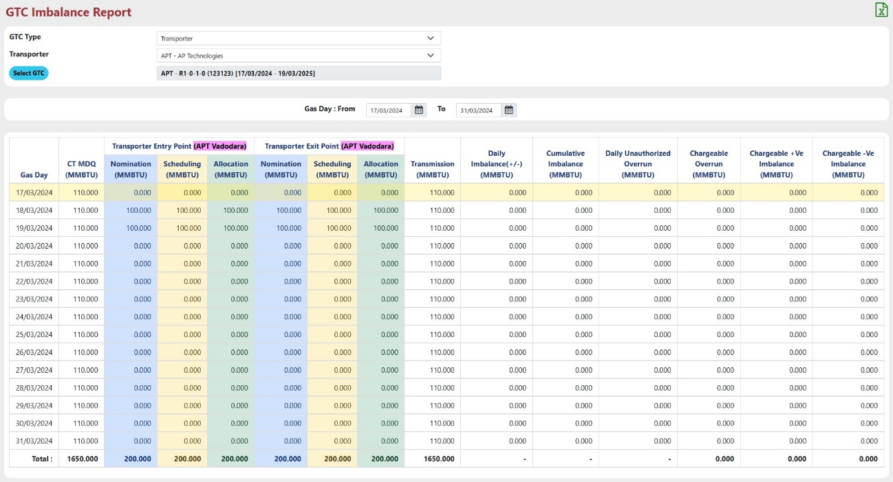
- Select GTC: Select Transporter Contract using “Select GTC” button.

Auditing

The "Audit Trail" within the "Admin" module comprehensively tracks and stores all user actions performed across the various sub-menus of the "Transport" module, providing a detailed record of changes made to the system's master data.

